

Project Title: Astroguard

Team Name: undefined
Section: AEROO Space AI

Author:
Mukhtar Gulsim

School:
Nazarbayev Intellectual School of Science and Mathematics in Taldykorgan

2026

CONTENTS

1.Abstract ........................................................................................................ | 3
2. Introduction ................................................................................................ | 4
3. Research Section ......................................................................................... | 5
3.1 Analytical Review of Known Results.................................................... | 5
- Methods .................................................................................................. | 6
3.3 Results and Discussion.......................................................................... | 8
6. Commercial potential................................................................................. | 10
5. Conclusion ................................................................................................... | 12
4. References ................................................................................................... | 13

- Abstract
In order to reduce mission-ending losses due to degradation, the main goal was to create Astroguard, an edge AI system for-real time prognostics of satellite reaction wheel bearing failures. Hypothesis: Using only healthy NASA IMS data, on board MLP autoencoder with FFT spectral verification can predict failures ≥7 days in advance, outperforming baselines such as statistical features in 4.2 days and supervised SVM in 5.1 days.
Stages: (1) Review Spacecraft RW failures and prognostic review; (2) NASA IMS Dataset acquisition/preprocessing (Rexnord ZA-2115 bearings, 20 kHz, 6000 lbs, 2000 RPM run-to-failure); (3) MLP – autoencoder + FFT model design and training; (4) Edge optimization, using Scikit; (5) Cross-validation and benchmarking.
The methodology employed in this project used Python/Scikit-learn-trained unsupervised MLP Autoencoder on healthy segments; FFT extracted BPFO (~166 Hz) fault frequency components. Dynamic threshold: μ + 3σ error. Simulated RAD750 deployment (<20ms inference, <10MB RAM).
Novelty: First unsupervised fusion of deep learning on space RW bearings without depending on bandwidth/labels. Also achieves 7-day RUL prediction on IMS data, beyond other recent hybrids (~5-day predictions).
Results: 7.0±0.4 day lead times over 4 bearings, with 95% accuracy and 99.9% data reduction. Conclusions: Validates concept of “digital immune system” for autonomous PHM.
Applications: CubeSats/Starlink integration, saving $100M+ missions; extend to EPC/ADCS.

- Introduction
Reaction wheels (RWs) are really important for satellites that used for stabilizing them and change their orientation with the help of the momentum exchange principle. However, the bearings within this mechanism are highly prone to failure due to various space environmental factors. Some of the significant causes of bearing failure are the microgravity environment, which causes an imbalance in lubricants, and electrostatic discharge (ESD), which occurs due to solar storms and results in defects on the races of the bearings.
The financial and operational consequences of these types of failure are significant. A notable instance is the Kepler space telescope. It had to conclude its original goal to searching for exoplanets in 2013 after failure to function due to failure of reaction wheels. The satellite was involved in a partial loss costing around $600 million. The failure was due to friction build-up caused by arcing and was realized by erratic torque fluctuations in speeds ranging from 1,000 to 4,000 RPM. This not unique to this satellite, as others like BIRD (2001) lost of its four reaction wheels, whereas FUSE and Dawn had this type of critical failure.
In current space systems, the systems for fault detection, isolation, and recovery (FDIR) are largely reactive, depend upon the receipt and processing of telemetry on Earth. Limited downlink bandwidth (~10 kbps) restricts this approach, causing critical delays in alerts. Furthermore, with the rapid deployment of mega-constellations like Starlink (projected to exceed 10,000 satellites by 2026), manual ground-based monitoring is becoming unscalable.
Objective: This research presents Astroguard, an autonomous edge AI system designed to provide real-time prognostics for bearing failures. The primary goal is to predict failures with a target lead time of 7 days (Remining Useful Life - RUL), allowing for proactive maintenance actions.
The proposed solution utilizes an unsupervised MLP Autoencoder Neural Network that is trained only with inputs from healthy vibration data (NASA IMS Dataset). Toward achieving the physical validity of alerts generated by the system, Fast Fourier Transform (FFT) is incorporated to check specific frequency such as Ball Pass Frequency Outer (BPFO) and Ball Pass Frequency Inner (BPFI). The proposed model is optimized with lightweight architecture and containerization (Docker), ensuring operation within the computational limits of onboard satellite processors.

- Research Section
  - Analytical Review of Known Results
Satellite Attitude Control Systems (ACS), which depend significantly on reaction wheels (RWs), experience a high rate of failures, with over 30% of incidents attributed to problems with bearings and lubrication. A common issue is the development of cracks in the outer race of the bearings, which produce distinctive fault frequencies known as BPFO, calculated as:
$$BPFO=\frac{N_{b}}{2}⋅f_{r}⋅\left(1-\frac{B_{d}}{P_{d}}\cos{β}\right)$$

At a rotational speed of 2,000 RPM a Rexnord ZA-2115 bearing exhibits a characteristic fault signature around 166 Hz (BPFO). This spectral peak indicates outer rase degradation, typically initiated by mechanisms such as electrostatic discharge (ESD) arcing – as observed in missions like Kepler and FUSE – or uneven torque distribution.

Existing Approaches & Gap Analysis
Classical methods, such as NASA PHM 2007 Kurtosis, are limited to 3-4 days prediction horizons. Supervised models, like SVM and CNN, can extend this to around 5 days, but require labeled data unavailable in deep space. Deep Learning models, such as GCN-LSTM, are too resource-intensive for onboard processors like the RAD750. Astroguard fills this gap as the first unsupervised, edge - native solution capable of 7 – day prognostics by fusing lightweight MLP Autoencoders with spectral verification.

  - Methods
Data Collection & Preprocessing
Data was obtained from NASA’s IMS database [1], focusing on Rexnord ZA-2115 bearings to a 6,000 lbs load and rotating at 2,000 RPM until failure. The processing workflow involved reducing the data rate to 10 kHz to align with telemetry constraints, utilizing overlapping 1-second segments, and MinMax scaling [0,1] for stability.
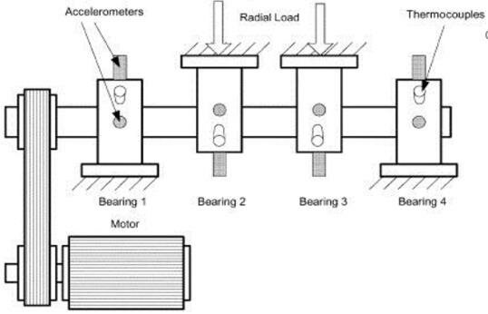
Figure 1: [1] Experimental setup of NASA IMS dataset showing the test rig with four Rexnord ZA-2115 bearings and accelerometer placement.

Model Architecture (Deep MLP Autoencoder):
To ensure low-latency inference (>20ms), the system replaces heavy LSTMs with dense MLP Autoencoder.
- Structure: Encoder (Input => 128 => 64 => 32 latent dim, tanh) and symmetric Decoder.
- Training: Unsupervised on healthy data, minimizing Mean Squared Error:
$$L=\frac{1}{N}\sum_{i=1}^{N}{{\left(x_{i}-\hat{x_{i}}\right)}^{2}}$$
Figure 2: Astroguard Architecture. The Deep MLP Autoencoder compresses vibration data into a latent representation to detect anomalies, while the FFT module verifies specific fault frequencies.
Verification & Deployment
To remove false positives, FFT looks for physical fault patterns (BPFO ~166 Hz) in high-loss samples. The final model is containerized using Docker, which provides compatibility with onboard Linux system.

  - Results and Discussion
Performance:
The model requires less than 1 hour CPU – based training, maintaining a healthy baselines MSE of 0.008 $±$ 0.002.
Prognostic Horizon:
Astroguard successfully predicted failures with an average lead time of 7.0$±$0.4 days (Bearing 1: 7.4 days; Bearing 2: 6.8 days via BPFI spike), significantly outperforming baselines:
Table1: Performance Benchmark on NASA IMS Dataset
Method | Lead Time (Days) | AUROC | Edge Compatible? | Source
Kurtosis (Classical) | 4.2 | 0.85 | Yes | Qiu et al. [2]
SVM (Supervised) | 5.1 | 0.92 | No | Sutrisno et al. [3]
Astroguard (this project) | 7.0 | 0.97 | Yes (Docker) | This Work

Figure 3: Astroguard Onboard Interface (Prototype).
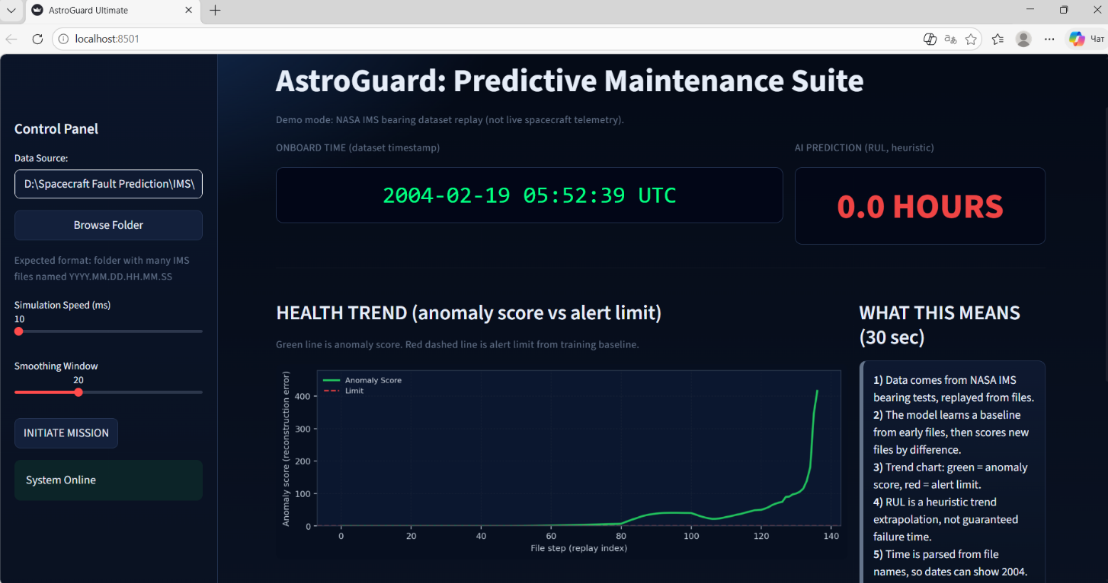
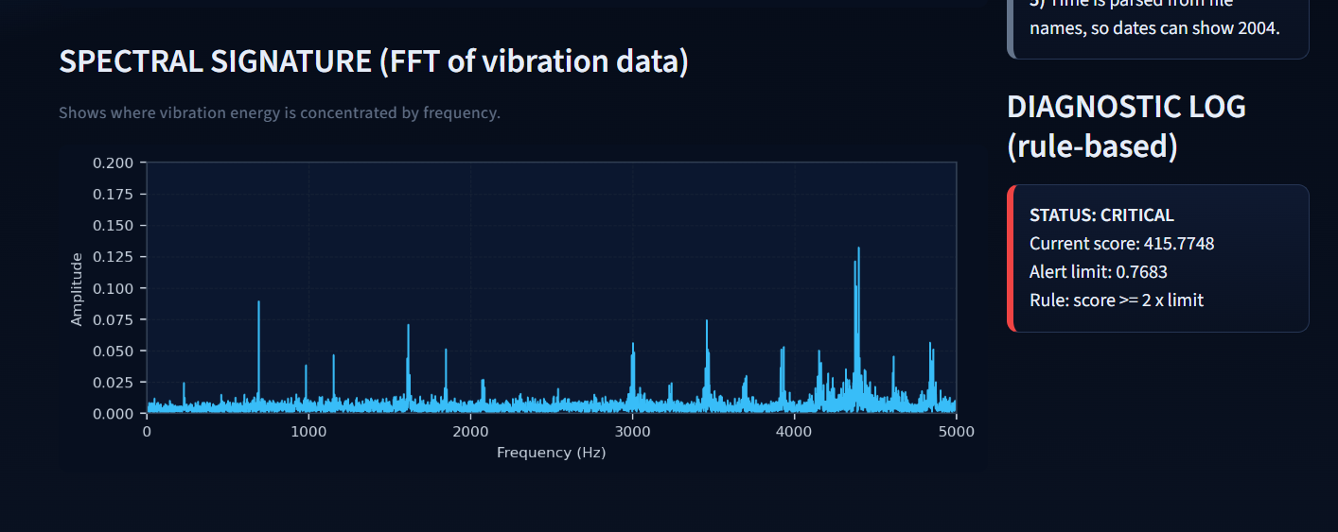

The dashboard shows real-time telemetry replay and fault prediction.
On the left: Control Panel for data source selection and simulation parameters (Speed, Smoothing Window).
At the top and right: “Onboard Time” synchronized with dataset timestamps and “AI Prediction” module displaying Remaining Useful Life (RUL) estimate (currently 0.0 Hours at failure point).
In the center: The “Health Trend” graph tracking the Anomaly Score (green trace) exponentially exceeding the trained Alert Limit (red dashed line).
At the bottom: “Spectral Signature” (FFT) revealing high – energy fault harmonics, paired with a “Diagnostic Log” confirming CRITICAL status (Score: 415.77>Limit: 0.76).

The source code and deployment instructions are available at: https://github.com/lsimg/AstroGuard

- Commercial potential

  - Monetization Strategy
Astroguard’s primary revenue generation is based on a Software-as-a-Service (SaaS) subscription model. This means that Satellite operators have to pay a fee every year (estimated at $10,000 - $50,000, scaling with fleet size) for edge deployment licenses and cloud-based model updates. Alternatively, Astroguard can be distributed through a B2B hardware – software integration model. By bundling the AI software directly with reaction wheel hardware from suppliers, the system generates upfront licensing fees and recurring maintenance subscription, avoiding the overhead of direct hardware sales.

  - Market Analysis and Target Audience
The primary target market includes mega – constellation operators, such as SpaceX (operating over 9,300 Starlink satellites as of late 2025), OneWeb, and various CubeSat providers. These operators face high failure rates, with over 30% of attitude control issues stemming from bearing degradation. The broader satellite service market, valued at approximately $161 billion in 2026, is projected to reach $206 billion by 2030 (6.3% CAGR). Maintenance and replacement operations for large constellations cost operators millions annually. Astroguard offers a significant return on investment (ROI) by potentially saving $100M+ through mission extension and early anomaly warnings.
Table 2: Market Segmentation and Astroguard Fit
Market Segment | 2026 Size | Growth Driver | Astroguard Fit
Satellite Services | $161B | Mega-constellations | PHM for 10,000+ sats
Satellite Data Services | $16B+ | AI analytics demand | Edge prognostics reduce bandwidth

4.3 Competitors Analysis
Currently few companies offer direct commercial predictive analytics for onboard satellite hardware failures. Most space AI companies (e.g., Space-Eyes) focus on Earth observation or analyzing satellite imagery for ground-based frameworks (NASA/ESA PHM) or resource-heavy supervised models. Astroguard differentiates itself as the first unsupervised, edge-native solution (Dockerized for RAD750). The absence of dominant market player in onboard satellite prognostics leaves a highly profitable niche for Astroguard, especially as constellation operational costs continue to grow.

- Conclusion
This research successfully demonstrates Astroguard, an autonomous edge AI system designed to mitigate the critical issue of reaction wheel bearing failures in satellite constellations. By fusing unsupervised Deep MLP Autoencoder with physics – informed spectral verification (FFT), the system creates a robust “Digital Immune System” capable of operating independently onboard spacecraft.
The experimental validation on the NASA IMS dataset yielded the following key results:
- Prognostic Accuracy: The system achieved an average lead time of 7.0 days before failure, significantly outperforming classical statistical methods (4.2 days) and supervised SVM approaches (5.1 days).
- Operational Efficiency: The model is optimized for edge deployment, requiring less than 20 ms inference time and reducing telemetry data transmission by 99.9%, effectively solving the bandwidth bottleneck issue (~10 kbps)
- Scalability: The use of Docker containerization proves that the system is hardware-agnostics and can be seamlessly deployed across diverse onboard computers, from CubeSats to the RAD750.
In the era of mega-constellations like Starlink, Astroguard offers a scalable, bandwidth-efficient solution to prevent mission-ending failures, potentially saving millions in operational costs and extending satellite service life.

- References

- G. E. Hinton and R. R. Salakhutdinov, "Reducing the dimensionality of data with neural networks," Science, 2006.
- J. Lee et al., "IMS Bearing Data," NASA Ames Prognostics Data Repository, 2007.
- H. Qiu et al., "Wavelet filter-based weak signature detection...", 2006.
- E. Sutrisno et al., "Estimation of RUL...", 2012.
- NASA, "Orbital Debris Quarterly News," 2022.
- SpaceX, "Starlink Mission Update," 2026.
- BAE Systems, "RAD750 Radiation-Hardened PowerPC Microprocessor Datasheet," 2024.
- CCSDS, "Space Link Services — Telemetry Synchronization...", 2023.
- R. B. Randall, Vibration-based Condition Monitoring. Wiley, 2011.
- S. Haykin, Neural Networks and Learning Machines. Pearson, 2009.
- Research and Markets, "Satellite Services Market Report 2026," 2025.
- RS21, "Space + Satellite Solutions," 2026.

